T5 Challenge Introduction
This guide is not intended as a strict true way forward, but as a series of suggestions based on our experiences. Herein we outline some 24 challenges (cblock) that can be completed with reasonable efficiency after defeating the fifth titan.

The primary requirement for these challenges is 5000 levels in each of the challenge NGUs (cNGUs) that are readily accessible at this stage: Power, Augments, Windows and Gold. You may need a certain T5 drop to accomplish this. One of us chose to complete them at 8400 cNGUs instead, but the differences in times were minor.

Note that you will benefit from running magic beards, i.e. reverse hitler + fu manchu + ladybeard[optional]. Remember that they only start growing at full magic cap.

Another helpful ability is rich jerks’ attack/defense boosts in the experience tab. 1,000% in each is not too expensive and allows to push a boss further.

Consider making a manual save file before starting challenges if your cNGUs are below 5000.

Note that troll and no rebirth challenges are the only critical ones. Others can be delayed.

T5 Challenge List

Name | Abbreviation | Number of completions | Difficulty scales? | Expected completion time per challenge
100 levels | 100lc | x5 | No | 40 minutes
No augmentations | noaugs | x5 | No | 1 hour
No time machine | notm | x3 | Yes | 1 hour - 5 hours or afk
Blind | blind | x1 | Yes | 30 minutes
No equipment | nec | x5 | No | 1 hour
Troll | tc | 1-3 | Yes | 45, 60, 80 minutes
No NGU | nongu | x1* | Yes | 1 hour
No rebirth | norb | 2-4 | Yes | <3 hours each or afk
24 hour | 24h | 1** | Yes | <1hour

T5 Notes on order
It’s best to do either 100lc or noaugs first in their entirety since one makes the other easier. Notm makes other challenges easier but takes a long time after notm1. It’s recommended to fit it in to away from keyboard (afk) parts of your day after the first challenge. The same goes for norb challenges. Notm 2-3 are skippable.

*Consider doing nongu 2-3 too depending on how long they take.

**You should complete 24h last as part of your normal post-challenge rise back. Complete just one 24h that you haven’t done.

All the other challenges can be done in any order.

T5 Tips for individual challenges

100级挑战
关掉胡子避免它占用等级上限。
如果你不能迅速抵达 boss30，那你怎么分配等级都是无所谓的。
一开始你可以在 Windows 98 里的能量和魔法里平均分配等级上限。在你能获得10或者100的增数时重生。
一旦你解锁了挂件，可以在合适的挂件与Windows 98中分配等级。
当你打败boss30后。在时间机器中分配 59 级的能量等级和 10 级的魔法等级用来提升黄金产出。剩下的等级分配到能量飞弹里。
在打败boss37之后，继续分配一些等级到能量飞弹里,剩下的等级分配给血魔法。
继续快速重生 (3min~10min) 直到遇见最后几个boss。之后可以专注提升能量飞弹等级。
使用掘金者和力量果实推进boss。
在第一次完成100级挑战后，调整你的流程来提高下一次完成100级挑战的的速度。

无挂件

用wandoos98推进boss。
用血魔法获得增数快速重生。

无时间机器挑战

这是一个非常痛苦的挑战。
虽然金币掉率装备能提供一定的帮助。在这个挑战中将没有足够的黄金来运行挂件和血魔法。
攻防的提升主要依赖于wandoos 98。
你可以升1~2级合适的挂件。剩下的钱拿来释放一次合适的血魔法来增加重生增数。
记得穿上增加wandoss速度的装备。
这个挑战适合长时间的AFK挂机。
最后用力量果实来终结boss。

失明挑战
打法和基础挑战一致。
如图所示。 你可以通过将鼠标悬停在左侧的HP栏上来推断您的老板等级。
如果使用sci表示法，那么指数+2应该等于当前的boss等级。
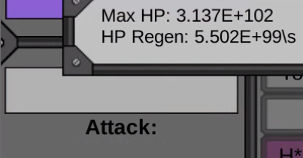

无装备挑战

这个挑战相当枯燥。无它。

整蛊挑战

整蛊挑战需要一些耐心和一点“作弊”技巧。
这个挑战的技巧在于：
通过将鼠标悬停在左下角的重生菜单按钮上来查看整蛊事件的倒计时。在整蛊事件倒计时剩余20S时提前保存。
如果整蛊事件为“摧毁一切”或“减少boss倍数”，且对进度影响较大，可以读档后立刻重生以减小事件损失（因为没什么可以被摧毁）。
除上述两个事件之外，等待整蛊事件出现后再考虑重生以跳过整蛊事件。因为整蛊效果通常不会持续到重生后。

无NGU挑战

当作基础挑战就好。

无重生挑战
一种办法是进行20-40分钟的高级训练来提升Windows速度。直到能满速提升 Windows MEH 的能量等级和魔法等级(尽量不要使用Windows 98)。
剩下的能量和魔法资源投入到时间机器和挂件中。
使用 Windows 、掘金者和力量果实推进boss。

24小时挑战

和基础挑战打法一致。

T5 Total expected reward
The base reward for all of these challenges is reported to be 277,000 AP and 113,000 XP (thanks to T-Bach from discord). This conflicts with the wiki estimate of 140,000 AP. Let me know if you see a differing result.

T6v2 Challenge Block Reference
A note on stats: please consult the stats of other users at the end of each reference as well. It is now widely considered that my stats for the next few blocks are high. E.g. OJ of Steel’s stats tend to be on the low end and suit a more active, speedrunning kind of player. You may find a sweet spot somewhere in between.

This block doesn’t require much guidance since you should feel comfortable with challenges by this point of the game. Here is a reference of my stats and the challenges I have done after defeating T6v2 as a rough reference.

My stats:
350k energy challenge NGUs each (most people recommend 250k),
Magic NGU: 80k power , 40k number, 20k time machine,
40 rich perks, 100,000% rich jerks (from spend exp->misc),
8500% fu, 300% reverse, 480% lady, 120,000% fopb
Caps: 100m e, 80m m

I finished all challenges except the last 5 notm and last 5 24h. I also did laser sword challenges separately since they don’t reset your number. No rb 10 took 2 hours and I finished no ngu 10 over night. Everything else was easy, mostly well under 30 minutes using 3 minute rb strategy.

Reference stats from OJ_of_Steel on discord, who had lower stats.

T7v2 Challenge Block Reference
See A note on stats in T6 block.

My reference stats are well over minimum requirements. I am guessing that one half of these NGU values would be fine.

My stats:
Evil E NGUs: 200k Augs, 128k Windows, 59k Gold, 5900 Power a
Evil M NGUs: 20k Power b, 3400 Number, 1400 TM
All rich perks, 1m % rich jerks
Evil Augs and Power A are most relevant here since they don’t have a softcap.

Name | Number Completed | Time in minutes | Notes
Basic | 4 (2-5) | 13
No time machine | 1 | 37
Blind | 1 | 22
Troll | 2 | 34, 56
No NGU | 1 | 180 | 30min rb
No rebirth | 6 | 9-120
Normal no tm | 5 (6-10) | 17-44
100lc/no augs |  |  | See note below

Note that you can take a McGuffin Muffin for the challenges to increase your guff stats for evil challenges, although at this point this is likely only relevant for whale players. It’s best used in the next block for nongu challenges since they have 30min rebirths.

Norb 6 is mandatory. Don’t bother if you are not going to do it. This is because it lets you kill the next titan in the first hour, and doing an additional challenge block just for that later means rebuilding AT banks again which is a chore.

People often do normal 24hr challenges for AP as well. Expect them to take more time. I heard reports that 24hr 10 takes ~2 hours. It should be easy to do more blinds, and some people recommend more nongu.

Here is another set of reference times and stats from discord user Grumia, who did it with much lower NGUs (⅓ of mine or so) but x2 my rich jerks and got good times. Yet another set of reference stats from discord user Evil Turtok, who got similar times. One more from Zhinjio via discord. And another one from xyperX™. A more recent example from ily.

Note: As of version 1.130 no augment and 100 level challenges are relevant again. Here are some reference stats including these challenges from discord user HarbingerOfDoom. Another set from OJ of Steel. Our final example is from CecilPL.

T8v2 Challenge Block Reference
See A note on stats in T6 block.

This challenge block should begin after all Typo gear is acquired - it doesn’t need to be maxed. This is because it’s a prelude to the first hack day. You can do these challenges earlier if you like.

My stats:
Evil E NGUs: 40m Augs, 34m Windows, 22m Gold, 3m Power a
Evil M NGUs: 6m Power b, 830k Number, 490k TM
10m % rich jerks
Hacks: 500 A/D, 350 TM, 300 Aug, 150 Blood, 40 Number
Base energy power 2.3m; base magic power 670k
Here’s a screenshot summary as well.

Name | Number Completed | Time in minutes | Notes
No time machine | 4 (2-5) | 8-43
Blind | 5 (2-6) | 6-26
Troll | 3 (3-5) | 19, 37, 63
No NGU | 6 (2-7) | 60, 90, etc | nongu 7 took >4 hours
No rebirth | 2 (7-8) | 10, 20
No equipment | 5 | 22
24 hour | 4 (1-4) | 2-69

The important challenges are troll 5, norb 8, and as many nongu as you can stomach. There will likely come a point where the next nongu will take much longer than the previous one. For me it was nongu 7 - so I stopped at that point.

You can do more challenges if you would like. I was able to complete the above in about 40 hours.

Here is a set of reference stats and times from discord user Promdates, and another one from Grumia (+50M rich jerks), and one more from XyperX. And last one from OJ of Steel.

T9v1 Challenge Block Reference
See A note on stats in T6 block.

This block assumes maxed t9v1 gear except the secret drop. Once again this is due to a followup hack day.

In this block we complete all remaining challenges except 24 hour ones. For me, troll 7 took 27 min, blind 10 - 21min, nongu 10 - 3 hours, notm 10 - 2.5 hours.

My stats:
Evil E NGUs: 150m Augs, 150m Windows, 130m Gold, 90m Power a
Evil M NGUs: 100m Power b, 70m Number, 70m TM
100m % rich jerks
Hacks: 2500 A/D, 2100 TM, 2000 Aug, 1800 Blood, 1400 Number
Base energy power 8.6m; base magic power 3.3m
Max A/D perks I and II, no A/D quirks or cards
Max A/D wishes I, Max EM power/cap/bars I
All double basic training - wish and quirk.
Here’s a screenshot summary as well.

Make sure you have enough non-ngu bonuses to finish nongu 10 in reasonable time - otherwise the challenges are easy. I also used EM delta potions for troll and nongu challenges, because it didn’t seem to be worth saving them, and I wanted to suffer less. Ditto for EM barbars for troll.

Here is a set of reference stats and times from discord user Promdates. And a set from Grumia.

Sad Arrival Challenge Block Reference
This block’s main purpose is norb and a bunch of xp/ap rewards. Here are the challenges I completed in a day and a half with some notes. I used gamma potions and a muffin for these.

Disable auto-nuke to avoid missing out on greater xp rewards with xp digger.

My stats were the same as last block except:
Evil NGUs 200-330m levels.
Max A/D wishes II and III

I completed the following 44 challenges:
all basic
all noaugs
3 24hr
all 100lc
all neq
all norb
2 troll
0 lsc
4 blind
1 nongu - obnoxious, ~90min
4 notm

Sad Troll
Troll sucks, life goes on. I completed tc7 in 31 minutes with the stats below. I managed to get to boss 152 with about 1/10th of these sad NGUs in a previous run at the 1 hour mark but gave up since I didn’t want to save scum a 30min rb for the win. Thanks to OJ for formatting work.
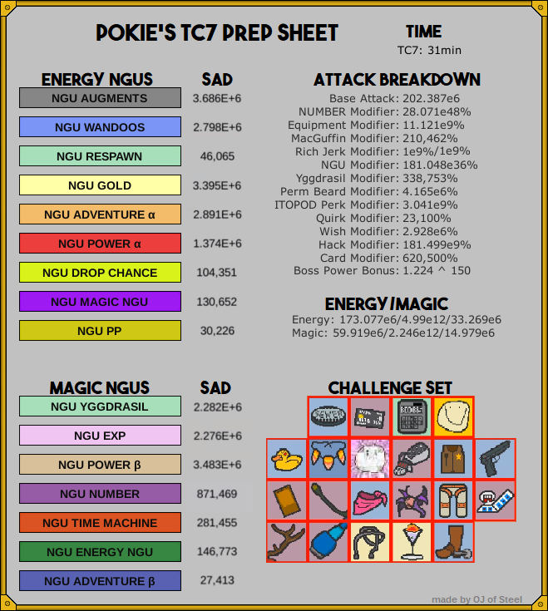

Sad 24 Hour 10
My reference stats. All relevant perks, quirks, and wishes are complete.

This little reference brought to you by

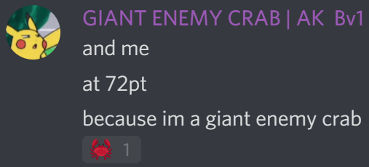


Endorsements:


Shameless Evil Plug
Here’s an evil guide.

